**P1 – How Alphanumeric data e.g. test vs. stored**

**ASCII**

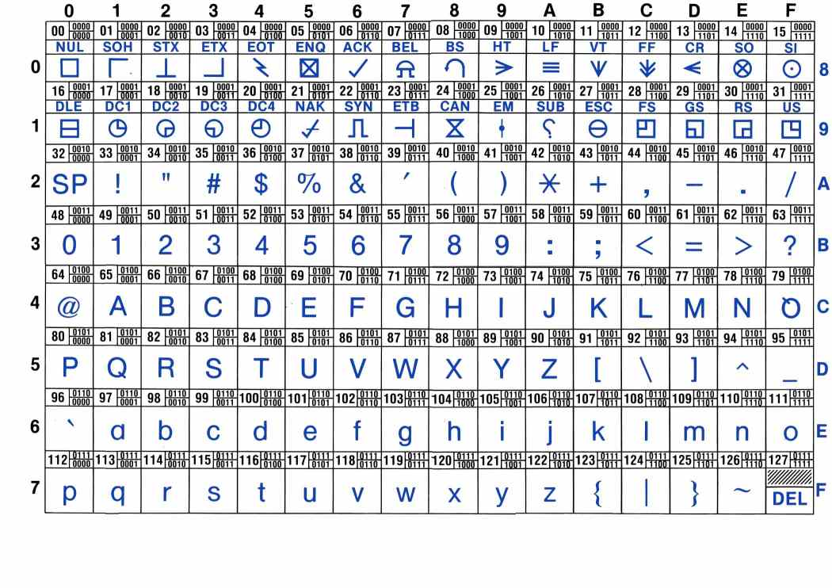The American Standard Code for Information Interchange (ASCII) is an American industry scheme, which is based on the English alphabet. It assigns letters, numbers and other characters. It ranges from 0-9 numbers, A to Z letters and different characters that are placed on the keyboard. It encodes 256 (28) configurations in a 7-bit byte. Different bytes are represented for different languages. 0 to 127 characters are represented to cover all the languages in the world. This was made to provide a code for every computer. This is used to code computers. An example could be C, the code for it is 01000011. Referring to the image below, it demonstrates how the ASCII standard table looks like. It looks complicated, but I will break it down for you. The symbols represent the keyboard keys, slightly above it, it shows the code of each one. For example 9, it would be 00111001. **Figure 1.1**

**Extended ASCII**

Extended ASCII, also known as high ASCII, is a larger character encodings that includes eight ASCII. This is the other half of ASCII. ASCII has a character of 128 and this one includes even more. This runs through 0 to 256. This is used for foreign languages as well. This means people who have different language from different country use different keyboards. This ASCII shows the extended language of it. For example, China speak Chinese. They will have different keys on the keyboard for the computer to understand. The chart below shows the Extended ASCII. For example, the decimal 131, it might be used for users who speak French.

For example, an ‘**é’** on the ASCII table would be 1110 1000.

**Example**

1. **Divided by 2** would represent like this ‘0011 0001’ ‘0011 0000’ ‘1111 0111’ ‘0011 0010’. It is long, but this is how it would be represented in ASCII.

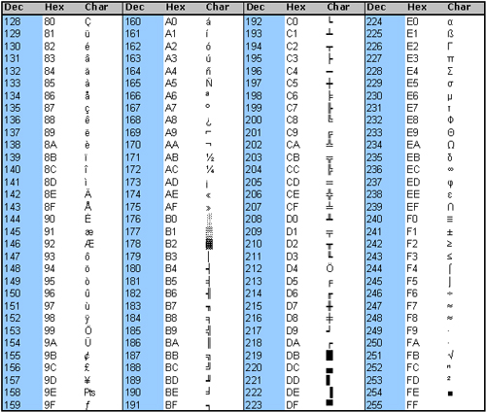

**Unicode**

Unicode is another set that maps binary combination together to character. The maximum with ASCII is 256. The problem is that Chinese people need to know over 2000 characters. Therefore, Unicode has a character over 100 000. There is a 16 bit version of Unicode and there is 32 bit version of the character. An example of a 16 bit Unicode would be 32 denary, which is SPACE in Unicode. The binary would be **0000 0000 0010 0000**. Obviously, 32 bit would be much longer. And, the table for Unicode is very long.

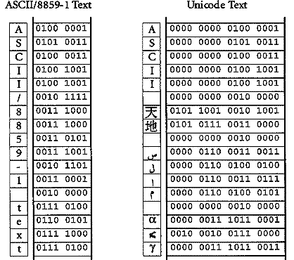This picture only shows a bit of the Unicode. As you can see, they are different symbols to represent different languages. These only show 2-5 of a different part of a language.